BUILD AND RUN COMMAND:
mvn packagejava -jar target/springbootmongodb-0.0.1-SNAPSHOT
CMD OUTPUT:
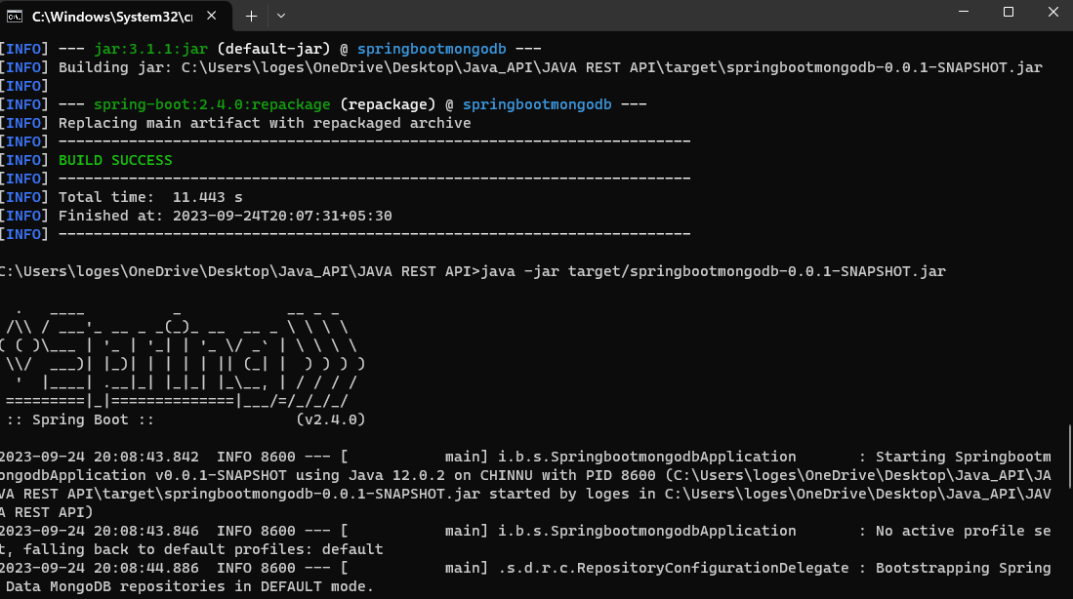

POSTMAN FOR GET, PUSH,DELETE
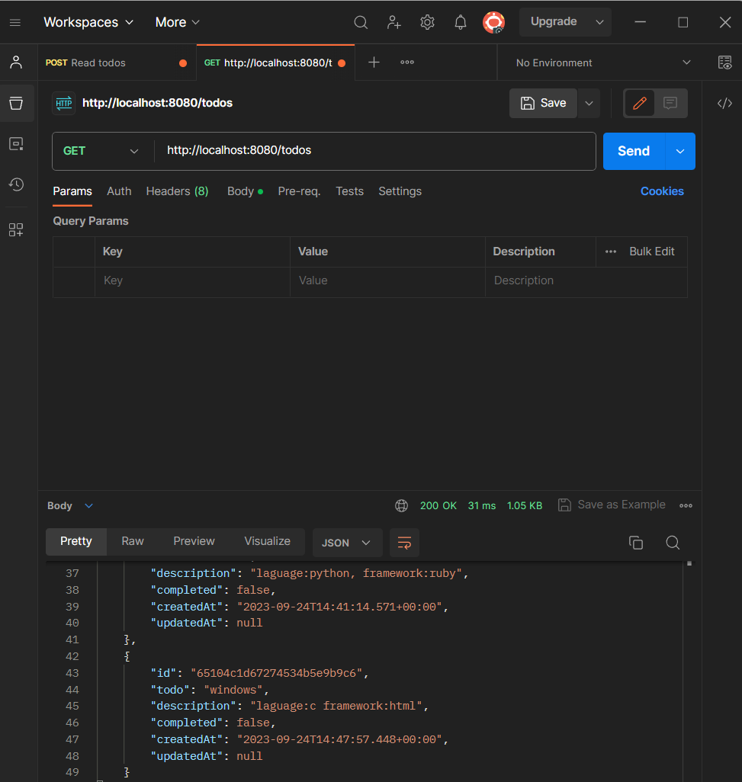

ROBO 3T DB_OUTPUT
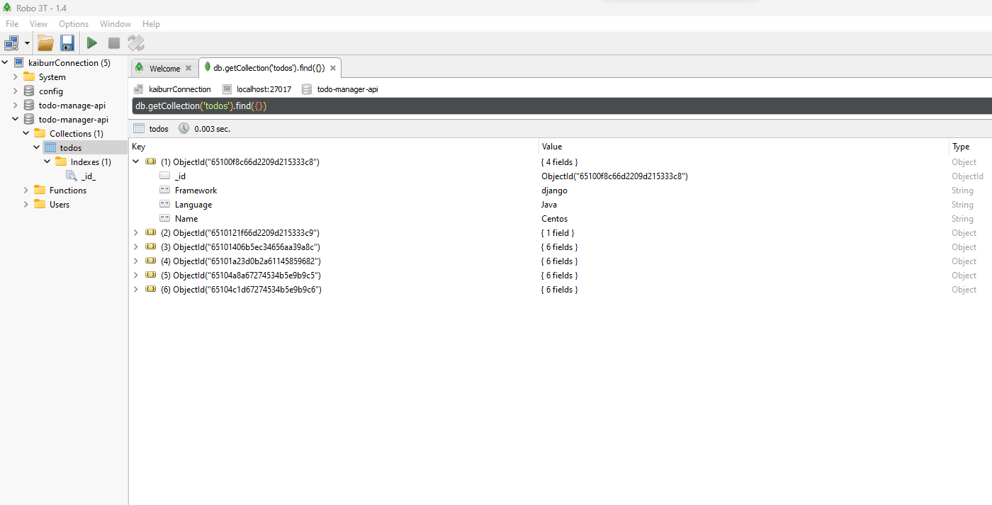

MONGODB OUTPUT:
